**PIZZA SALES SQL QUERIES**

**A. KPI’s**

**1. Total Revenue:**

select SUM(total_price) AS Total_Revenue from pizza_sales;



**2. Average Order Value**

select SUM(total_price)/COUNT(DISTINCT order_id) as Avg_Order_Value from pizza_sales;

**3. Total Pizzas Sold**

select SUM(quantity) as Total_Pizza_Sold from pizza_sales;



**4. Total Orders**

select COUNT(DISTINCT order_id) as Total_Orders from pizza_sales;

**5. Average Pizzas Per Order**

select CAST(CAST(SUM(quantity) AS DECIMAL(10,2)) / CAST(COUNT(DISTINCT order_id) AS DECIMAL(10,2)) AS DECIMAL (10,2)) AS Avg_Pizzas_Per_Order from pizza_sales;

**B. Daily Trend for Total Orders**SELECT DAYNAME(STR_TO_DATE(order_date, '%Y-%m-%d')) AS order_day, COUNT(DISTINCT order_id) AS total_orders

FROM pizza_sales

GROUP BY DAYNAME(STR_TO_DATE(order_date, '%Y-%m-%d'));

***Output:***

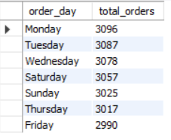

**C. Monthly Trend for Orders**

SELECT monthname(STR_TO_DATE(order_date, '%Y-%m-%d')) AS Total_Orders, COUNT(DISTINCT order_id) AS total_orders

FROM pizza_sales

GROUP BY monthname(STR_TO_DATE(order_date, '%Y-%m-%d'));

**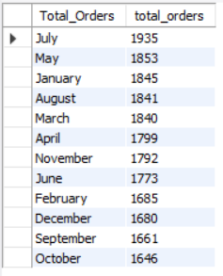*Output***

**D. % of Sales by Pizza Category**

select pizza_category, round(sum(total_price),2) as Total_Revenue, round(sum(total_price) * 100/(select SUM(total_price) from pizza_sales),2) from pizza_sales

group by pizza_category;

**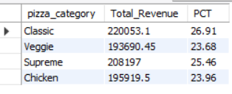*Output***

**E. % of Sales by Pizza Size**

select pizza_size, round(sum(total_price),2) as Total_Revenue, round(sum(total_price) * 100/(select SUM(total_price) from pizza_sales),2) as PCT from pizza_sales

group by pizza_size;

***Output***

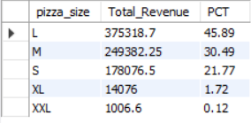

**F. Total Pizzas Sold by Pizza Category**

select pizza_category, SUM(quantity) as Total_Quantity_Sold from pizza_sales group by pizza_category

***Output***

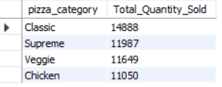

**G. Top 5 Pizzas by Revenue**

select pizza_name, SUM(total_price) as Revenue from pizza_sales group by pizza_name order by SUM(total_price) desc limit 5; 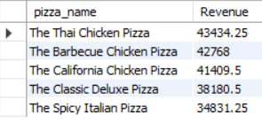

**H. Bottom 5 Pizzas by Revenue**

select pizza_name, SUM(total_price) as Revenue from pizza_sales group by pizza_name order by SUM(total_price) asc limit 5; 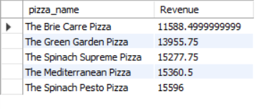

**I. Top 5 Pizzas by Quantity**

select pizza_name, COUNT(quantity) as Quantity from pizza_sales group by pizza_name order by COUNT(quantity) desc limit 5;

**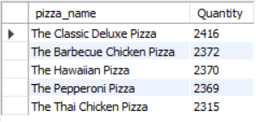*Output***

**J. Bottom 5 Pizzas by Quantity**

select pizza_name, COUNT(quantity) as Quantity from pizza_sales group by pizza_name order by COUNT(quantity) asc limit 5;

**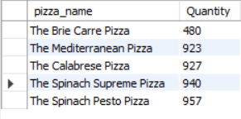*Output***

**K. Top 5 Pizzas by Total Orders**

select pizza_name, COUNT(distinct order_id) as Total_Orders from pizza_sales group by pizza_name order by COUNT(order_id) desc limit 5; 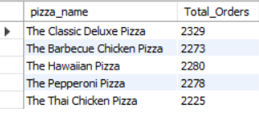

**L. Bottom 5 Pizzas by Total Orders**

select pizza_name, COUNT(distinct order_id) as Total_Orders from pizza_sales group by pizza_name order by COUNT(order_id) asc limit 5; 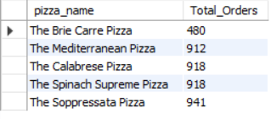

***NOTE***

If you want to apply the pizza_category or pizza_size filters to the above queries you can use WHERE clause. Follow some of below examples

SELECT Top 5 pizza_name, COUNT(DISTINCT order_id) AS Total_Orders

FROM pizza_sales

WHERE pizza_category = 'Classic'

GROUP BY pizza_name

ORDER BY Total_Orders ASC

select pizza_category, round(sum(total_price),2) as Total_Revenue, round(sum(total_price) * 100/(select SUM(total_price) from pizza_sales where month(STR_TO_DATE(order_date, '%Y-%m-%d')) =1),2) as PCT from pizza_sales

where month(STR_TO_DATE(order_date, '%Y-%m-%d')) =1

group by pizza_category;

